# 

# Fortune Theatre

Home of the Woman In Black

# Access Guide



Content:

# How to get here

# Choosing the best seat

# What to expect when you get here

# Venue Facilities

# Access Performances

# Access Membership

# Visual Story

How To Get Here

Fortune Theatre

Russell Street

London

WC2B 5HH

The Fortune Theatre is easily accessible by both road and train. The venue opens an hour and a half prior to the show and the auditorium opens 30 minutes before. Please allow enough time to get here and take your seats.

* Nearest Over ground Station- Charring Cross (10/15 mins walk)
* Nearest Tube Station- Covent Garden (3/5 mins)
* Taxi Rank- Covent Garden (30 seconds walk)

Choosing The Best Seat

The auditorium at the Fortune Theatre is small and intimate, the sight lines are good from all levels. All the stairs have hand rails and there are bars and toilets on each level.

**Stalls**

There are 21 steps down to the stalls. If you want to be close to the stage and amongst the action then booking a seat in the stalls is best for you. The stalls seats also have the best leg room.

**Dress Circle**

There are 7 steps up to the Dress Circle from the foyer. There is an alternative route that has less stairs and a stair lift for wheelchair patrons. If you have difficulty with steps then booking towards the back of the dress circle is best. If you are a wheelchair user who cannot transfer we have 2 wheelchair spaces at the back of the dress circle.

**Upper Circle**

There are lots of steps to the upper circle and the seating is quite steep. The sight lines are still good though.

What To Expect When You Get Here…

**A Front of House Team Member**

**The Auditorium**

**Box Office**

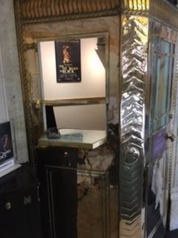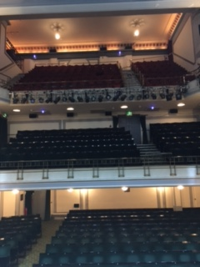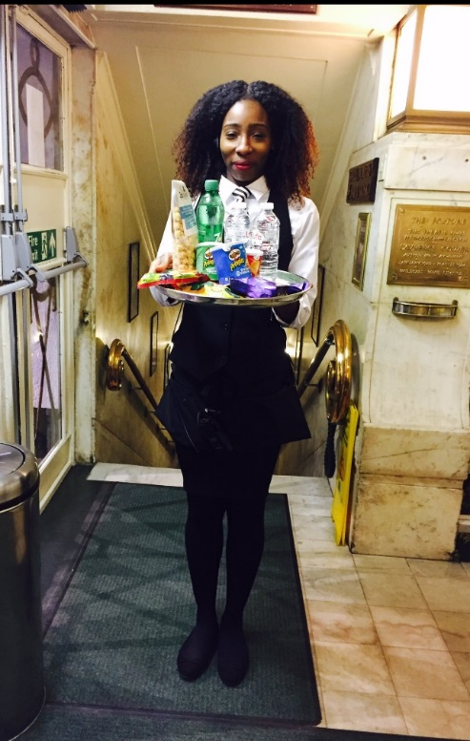

When you enter the foyer you can buy or collect your tickets from box office

The auditorium opens 30 minutes before the show starts. Check your tickets and take your seats

If you have any questions or problems while you are at the theatre, the front of house team are there to help. You can also buy drinks, snacks and merchandise from them.

Venue Facilities

**Access Lift**

We have an access lift which goes between street level and the dress circle auditorium, please ask the box office or a front of house member if staff to operate the lift.

**Access Toilet**

We have an access toilet which is step free access from street level or can be accessed using the lift or stairs in our dress circle. It has an emergency alarm to alert the front of house team if anyone requires immediate help.

**Sennheiser Stethosets**

We have 2 types hearing loop system, one that goes into your ears and amplifies all auditorium noise and one which connects to your hearing aid if it has a T setting. Our loop system works through an infra-red sensor on the devise, so make sure nothing is covering the sensor.

**Seat Service**

There are bars on every level of the theatre. None of our bars have step free access however we do run a seat service which means you can order from any usher from your seat and it gets delivered to your seat.

**Wheelchair spaces**

We have 2 wheelchair spaces in the theatre, they are located at the back of the Dress Circle. We have removable seats in this area so a companion or carer can accompany the wheelchair user. Please speak to box office or ring our access line to book a wheelchair space.

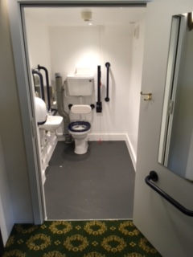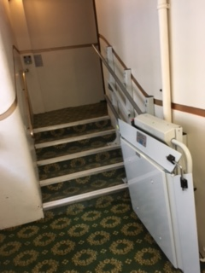

Access Performances

The Fortune Theatre has access performances of the Woman in Black, please check with box office or look on our website for scheduled dates.

<http://www.atgtickets.com/shows/the-woman-in-black/fortune-theatre/#showinfotabs=access>

Access Membership

If you want to making booking easier, join our Access Membership scheme at one of our ATG box offices or online. You fill in your specifications and it will recommend the best seating for you in any of our ATG venues.

<http://www.atgtickets.com/access/access-scheme>

Visual Story